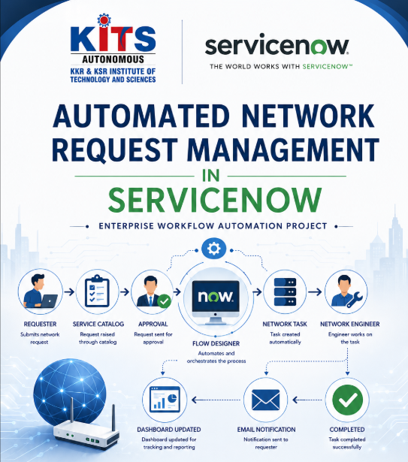
Submitted By: KUDARAVALLI SAI SIRI
College: KKR & KSR INSTITUTE OF TECHNOLOGY AND SCIENCES
Department: Computer Science and Engineering
Technology: ServiceNow
Project Type: Individual Project
Submission Year: 2026

ACKNOWLEDGEMENT
I would like to express my sincere gratitude to everyone who contributed to the successful completion of my project, "Automated Network Request Management in ServiceNow."
First and foremost, I express my heartfelt thanks to my faculty members, project guide, and the SmartBridge training team for their continuous guidance, valuable suggestions, encouragement, and technical support throughout the development of this project. Their mentorship provided me with the confidence to learn ServiceNow from the fundamentals and apply the concepts in a practical project.
I am grateful to my college management and the Department of Computer Science and Engineering for providing me with the opportunity to work on this project as part of my practical learning experience. This project has helped me bridge the gap between academic knowledge and real-world enterprise application development.
I would also like to thank ServiceNow for providing the Personal Developer Instance (PDI) and an excellent cloud-based development platform that enabled me to explore and implement various ServiceNow concepts, including Scoped Applications, Data Modeling, Forms, Service Catalog, Flow Designer, Business Rules, Client Scripts, UI Policies, Notifications, Reports, Dashboards, Security, and Workflow Automation.
Working on this project has significantly improved my understanding of IT Service Management (ITSM), enterprise application development, workflow automation, and business process optimization. It has also strengthened my problem-solving ability, logical thinking, analytical skills, and confidence in developing real-world ServiceNow applications.
Finally, I would like to express my sincere gratitude to my parents, family members, friends, and everyone who supported and motivated me throughout this project. Their constant encouragement inspired me to complete this work successfully.
I sincerely acknowledge and thank everyone who directly or indirectly contributed to the successful completion of this project.

TABLE OF CONTENTS
- 1. Project Overview
- 2. Business Objective
- 3. Problem Statement
- 4. Proposed Solution
- 5. Stakeholders
- 6. Requirement Analysis
- 7. Day 1 Development
- 8. Concepts Learned
- 9. Day 1 Conclusion

1. PROJECT OVERVIEW
Automated Network Request Management is a ServiceNow application developed to automate the complete lifecycle of network-related service requests. Employees can submit requests such as VPN access, firewall changes, Wi-Fi access, and network permissions through a centralized platform. The system automates approvals, task assignments, notifications, and request tracking, reducing manual effort and improving operational efficiency.

2. BUSINESS OBJECTIVE
The objective of this project is to automate the complete network request management process using ServiceNow. The application reduces manual effort, standardizes approval workflows, improves visibility of requests, provides faster service delivery, and ensures better compliance with organizational IT policies.

3. PROBLEM STATEMENT
In many organizations, employees request network services through emails or manual processes. These requests often experience delays, inconsistent approvals, poor tracking, and limited visibility. Managing requests manually increases administrative effort and makes auditing difficult.

4. PROPOSED SOLUTION
This project provides a centralized ServiceNow application that automates the complete network request lifecycle. Users submit requests through ServiceNow, approvals are automatically routed, fulfillment tasks are assigned to the appropriate network team, notifications are generated, and request progress is tracked until completion.

5. STAKEHOLDERS
Stakeholder | Responsibility
Requester | Submits network requests
Approver | Reviews and approves requests
Network Team | Performs network configuration and fulfills requests
Administrator | Configures and manages the ServiceNow application

6. REQUIREMENT ANALYSIS
- Functional Requirements
- Users should be able to submit network requests.
- Requests should be routed for approval.
- Network tasks should be created automatically.
- Notifications should be sent during important stages.
- Request status should update automatically.
- Reports and dashboards should provide request insights.
- Non-Functional Requirements
- User-friendly interface.
- Secure access using roles.
- Reliable automation.
- Scalable application design.
- Easy maintenance.

7. DAY 1 DEVELOPMENT

7.1 Requirement Analysis
The project requirements were analyzed to identify stakeholders, business problems, required data, workflow, and expected automation before beginning development.
Requirement Analysis:
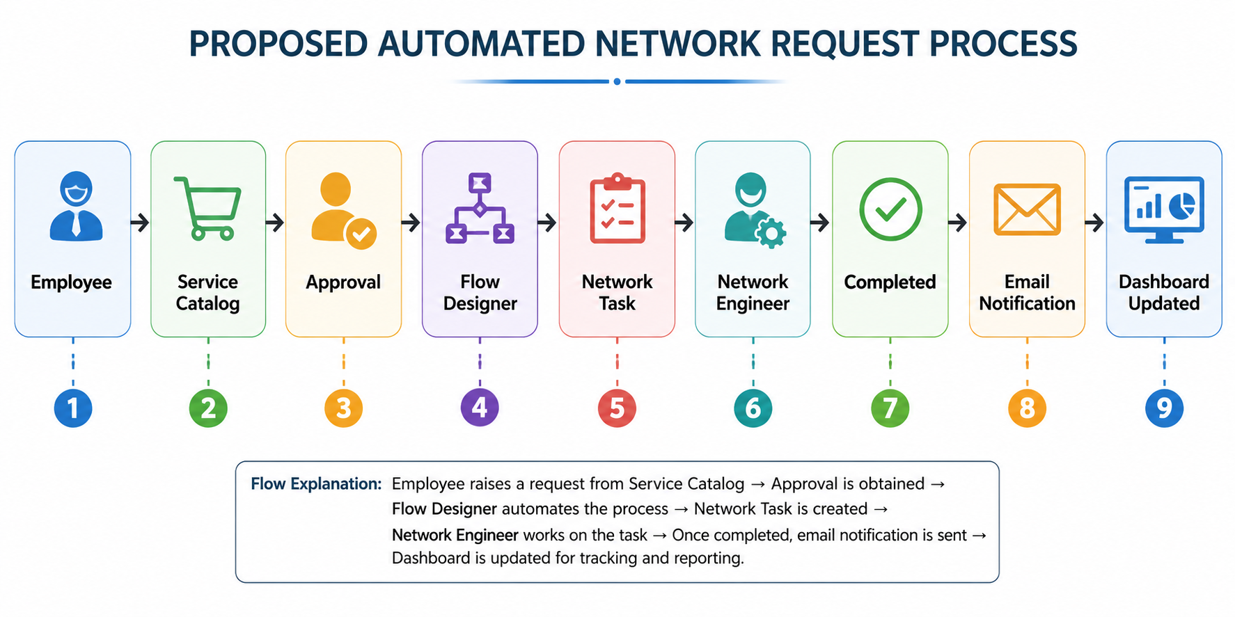

7.2 Scoped Application Creation
A new scoped application named 'Automated Network Request Management' was created in ServiceNow Studio. The scoped application isolates all project components such as tables, scripts, flows, and security configurations.
Create Application Page:
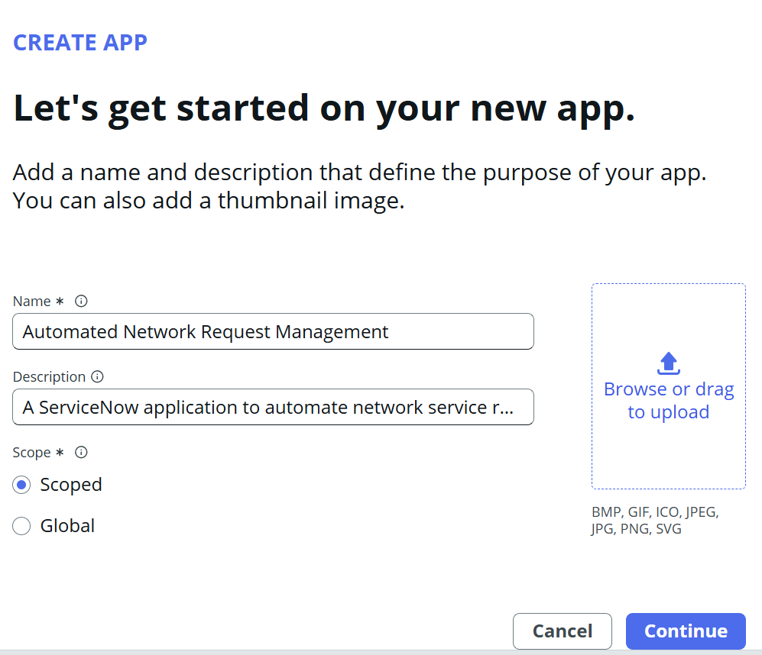
Application Created :
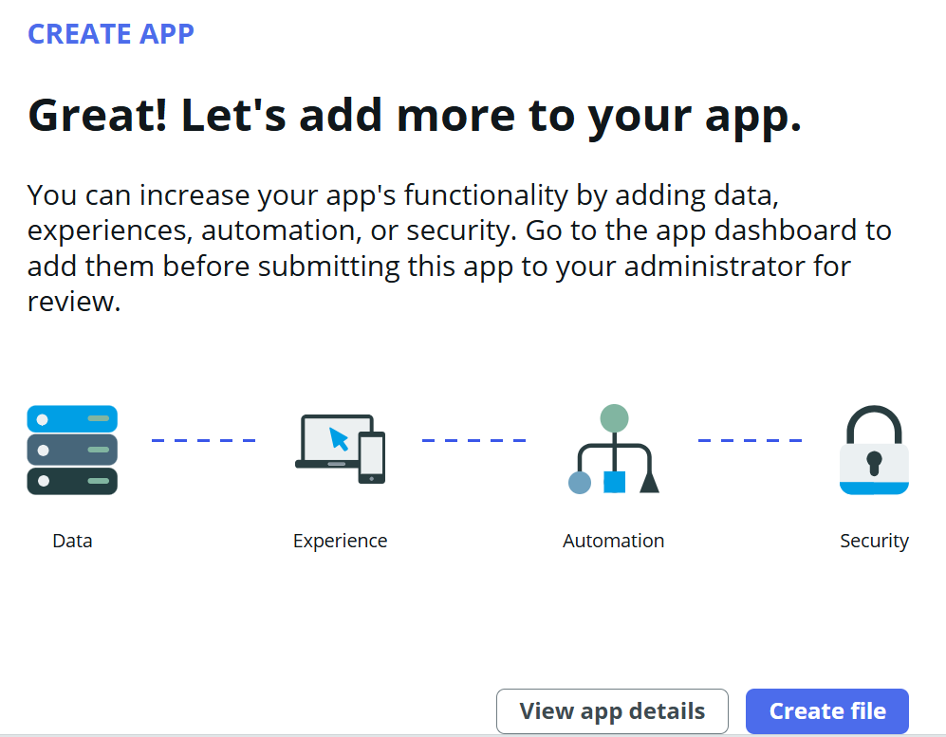
Add Data Options:
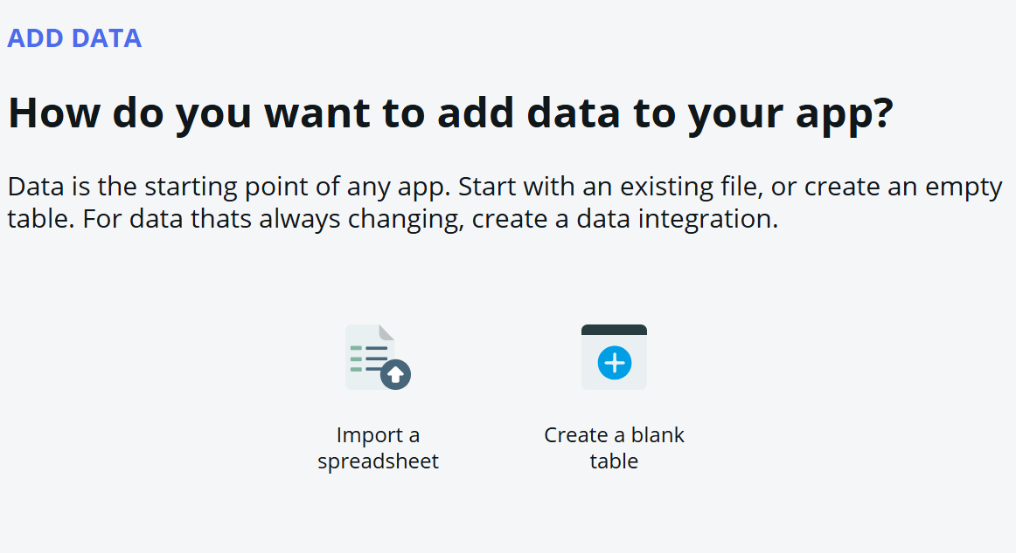

7.3 Default Roles
During application creation, ServiceNow generated default Admin and User roles. These roles will later be extended with custom roles such as Network Requester, Network Approver, and Network Engineer.
Default Roles :
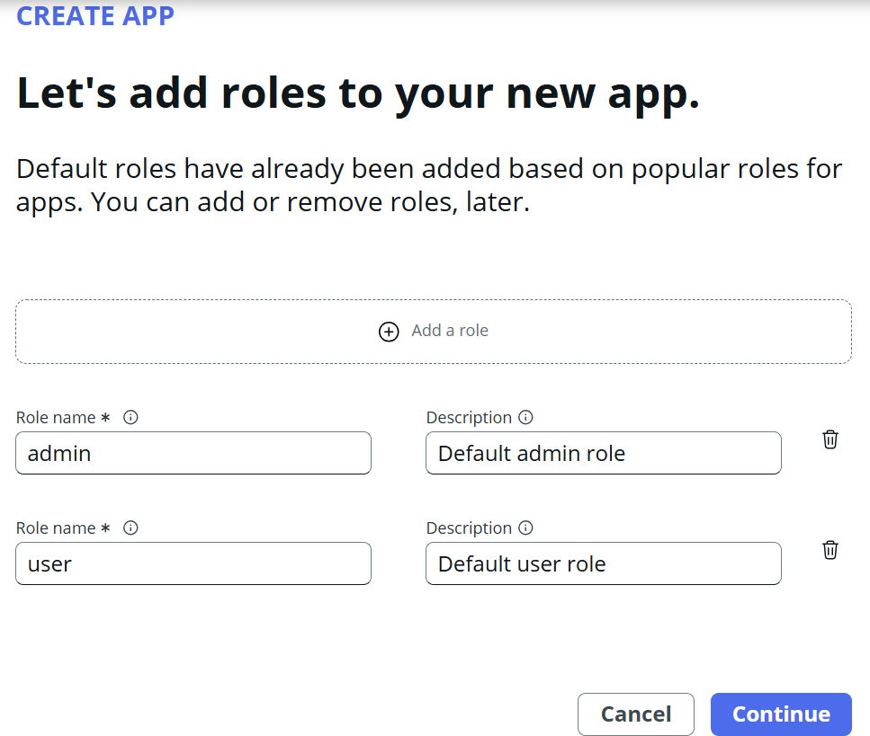

7.4 Network Request Table
A new table named 'Network Request' was created to store all network service requests. Auto Number was enabled to generate unique request numbers automatically. Basic table permissions were configured.
Table Details:
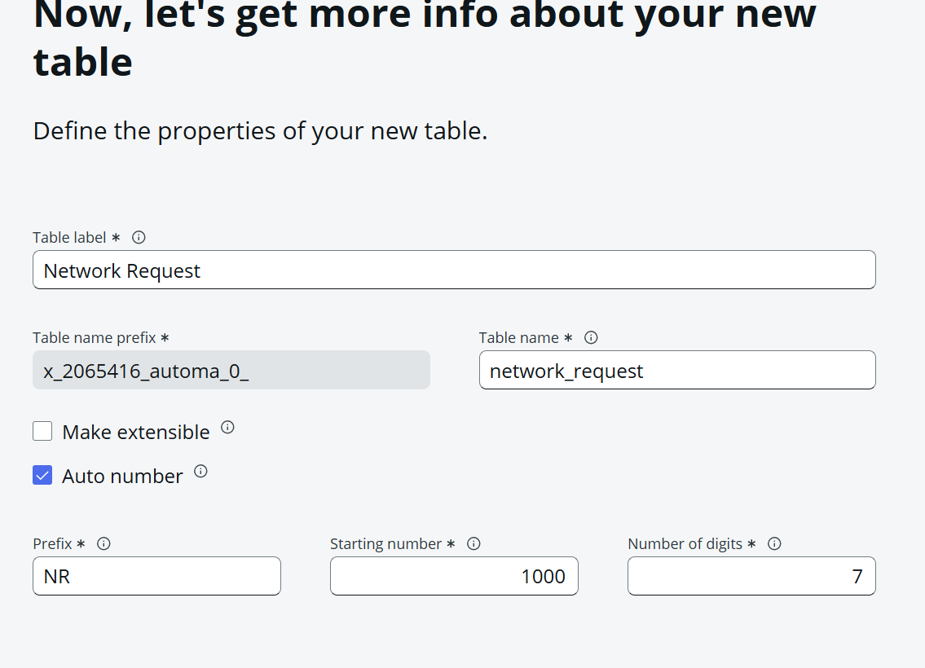
Table Permissions :
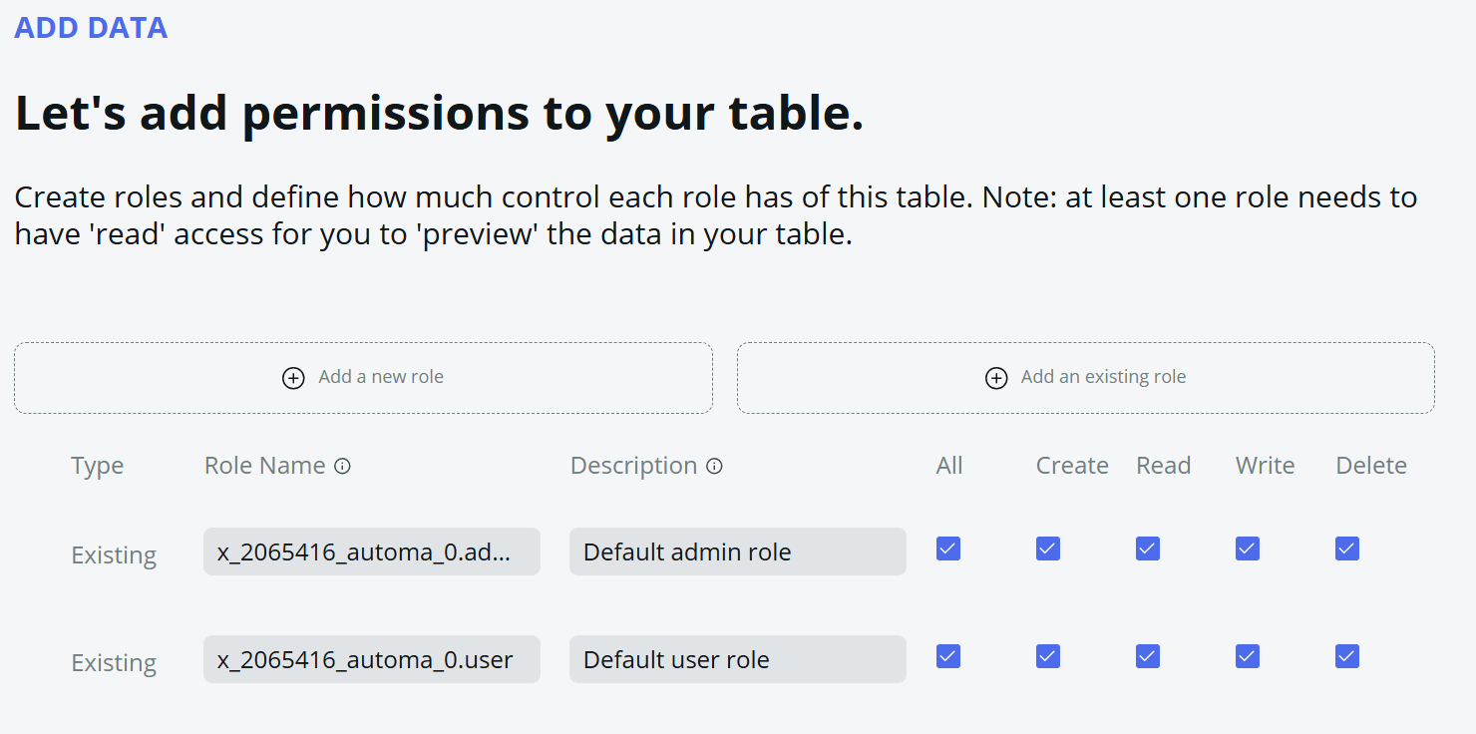

Table Created Successfully :
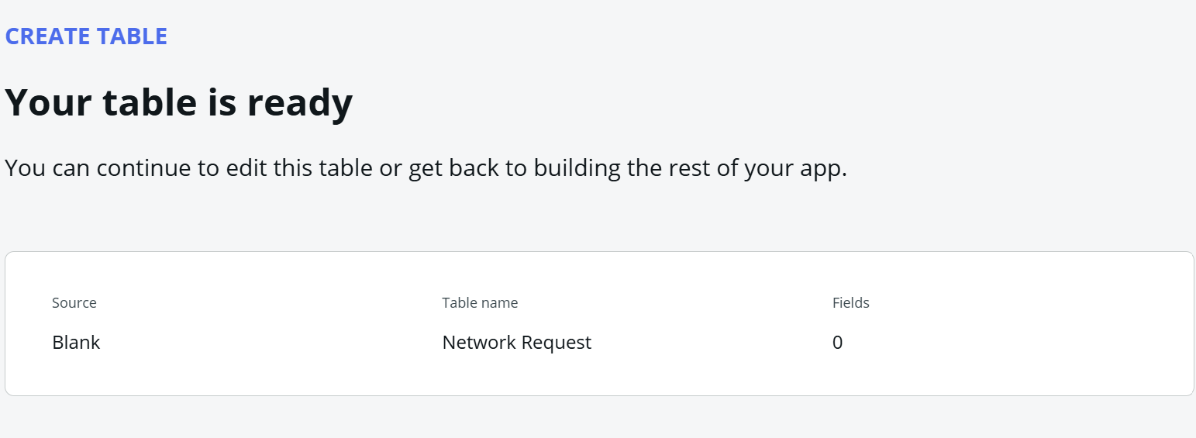

8. CONCEPTS LEARNED
Concept | Status
Requirement Analysis | Completed
Scoped Application | Completed
ServiceNow Studio | Completed
Users | Completed
Groups | Introduction
Roles | Completed
Table | Completed
Record | Completed
Field | Completed
Auto Number | Completed
Table Security | Introduction

9. DAY 1 CONCLUSION
Day 1 focused on understanding the business problem and building the project foundation. A scoped application was created, application roles were configured, and the primary Network Request table was designed and implemented. These activities establish the foundation for creating forms, fields, automation, approvals, and reporting in the upcoming development phases.

